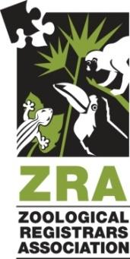
ZRA Annual Conference

Institutional Sponsorship Response Form

Name: __________________
Title: _______________________
Company: ____________________
Address: ______________________
Phone: __________________
Email: _______________________

Yes, I/my company would like to be a sponsor at the Zoological Registrars Association (ZRA) Conference at the level below:

☐ Gold Level -- $1,500
☐ Ice Breaker
☐ Zoo Day
☐ Z-CAP Session

☐ Silver Level -- $1,000
Please recognize me/my company at:
☐ Zoo Day Dinner Event
☐ Conference Lunch

☐ Bronze Level -- $500
Please recognize me/my company at:
☐ Session Break
☐ Pre-Conference Tour
☐ Post-Conference Tour

☐ General Sponsor -- $

Approval Signature: Date:

Payment Information

☐ Payment is enclosed: make checks payable to: Kansas City Zoo & Aquarium
Kansas City Zoo & Aquarium
Attn: Natalie Johnson, Registrar
6800 Zoo Dr.
Kansas City, MO 64132

☐ Payment will be made with credit card. Please click here to make a payment.

As confirmation of your company's participation please email this form to by 1 August 2024:

Kaylin Dunn
ZRA Annual Conference Committee Vice Chairman
Senior Animal Records & Data Manager
Kaylin.Dunn@seaworld.org
407-226-5182

